**Dharmsinh Desai University, Nadiad**

**Department of Information Technology**

**DAIE, IT704**

**B.Tech. IT, Sem: VII**

**Aim: - Create A master page and content Page Application for the University which enables user to see the faculty list according to department.**

**Code: -**

1. **Site1.Master**

<%@ Master Language="C#" AutoEventWireup="true" CodeBehind="Site1.master.cs" Inherits="Lab8.Site1" %>

<!DOCTYPE html>

<html>

<head runat="server">

<title></title>

<style>

body {

margin: 0;

font-family: Arial, Helvetica, sans-serif;

}

.topnav {

overflow: hidden;

background-color: #333;

}

.topnav a {

float: left;

color: #f2f2f2;

text-align: center;

padding: 14px 16px;

text-decoration: none;

font-size: 17px;

}

.topnav a:hover {

background-color: #ddd;

color: black;

}

</style>

</head>

<body>

<form id="form1" runat="server">

<div>

<div class="topnav" style="background-color:darkcyan">

<asp:HyperLink ID="HyperLink1" class="link" runat="server" NavigateUrl="~/WebForm1.aspx">IT</asp:HyperLink>

<asp:HyperLink ID="HyperLink2" class="link" runat="server" NavigateUrl="~/WebForm3.aspx">CE</asp:HyperLink>

<asp:HyperLink ID="HyperLink3" runat="server" NavigateUrl="~/WebForm2.aspx">EC</asp:HyperLink>

<asp:HyperLink ID="HyperLink4" runat="server" NavigateUrl="#">Dharamasinh Desai University</asp:HyperLink>

</div>

<div style="padding:20px;">

<asp:ContentPlaceHolder runat="server" ID="it"></asp:ContentPlaceHolder>

<asp:ContentPlaceHolder runat="server" ID="ce"></asp:ContentPlaceHolder>

<asp:ContentPlaceHolder runat="server" ID="ec"></asp:ContentPlaceHolder>

</div>

</div>

</form>

</body>

</html>

1. **WebForm1.aspx [IT-Dept]**

<%@ Page Language="C#" MasterPageFile="~/Site1.Master" AutoEventWireup="true" CodeBehind="WebForm1.aspx.cs" Inherits="Lab8.WebForm1" %>

<asp:Content ID="Content1" ContentPlaceHolderID="it" runat="server">

<h2 style="background-color:#FFFFE0;">IT Dept</h2>

<h3>Faculty List</h3>

<table border="4" bordercolor="black" style="background-color:#FFFFE0;">

<tr>

<th style="width: 319px">Name</th>

<th style="width: 285px">Designation</th>

</tr>

<tr>

<td style="width: 319px">Dr. Vipul K. Dabhi</td>

<td style="width: 285px">Associate Professor & Head</td>

</tr>

<tr>

<td style="width: 319px">Dr. Harshadkumar B. Prajapati</td>

<td style="width: 285px">Associate Professor </td>

</tr>

<tr>

<td style="width: 319px">Prof. Ravindra A. Vyas</td>

<td style="width: 285px">Assistant Professor </td>

</tr>

</table>

</asp:Content>

1. **WebForm2.aspx [EC-Dept]**

<%@ Page Language="C#" MasterPageFile="~/Site1.Master" AutoEventWireup="true" CodeBehind="WebForm2.aspx.cs" Inherits="Lab8.WebForm2" %>

<asp:Content ID="Content4" ContentPlaceHolderID="ec" runat="server">

<h2 style="background-color:#FFFFE0;">EC Dept</h2>

<h3>Faculty List</h3>

<table border="4" bordercolor="black" style="background-color:#FFFFE0;">

<tr>

<th style="width: 257px">Name</th>

<th style="width: 272px">Designation</th>

</tr>

<tr>

<td style="width: 257px">Dr. Purvang D. Dalal</td>

<td style="width: 272px">Associate Professor & Head</td>

</tr>

<tr>

<td style="width: 257px">Dr. H. S. Mazumdar</td>

<td style="width: 272px">Associate Professor </td>

</tr>

<tr>

<td style="width: 257px">Prof. Hetal B. Shah</td>

<td style="width: 272px">Assistant Professor </td>

</tr>

</table>

</asp:Content>

1. **WebForm3.aspx [CE-Dept.]**

<%@ Page Language="C#" MasterPageFile="~/Site1.Master" AutoEventWireup="true" CodeBehind="WebForm3.aspx.cs" Inherits="Lab8.WebForm3" %>

<asp:Content ID="Content1" ContentPlaceHolderID="ce" runat="server">

<h2 style="background-color:#FFFFE0;">CE Dept</h2>

<h3>Faculty List</h3>

<table border="4" bordercolor="black" style="background-color:#FFFFE0;">

<tr>

<th style="width: 252px">Name</th>

<th style="width: 287px">Designation</th>

</tr>

<tr>

<td style="width: 252px">Dr. C. K. Bhensdadia</td>

<td style="width: 287px">Associate Professor & Head</td>

</tr>

<tr>

<td style="width: 252px">Dr. Brijesh S. Bhatt</td>

<td style="width: 287px">Associate Professor </td>

</tr>

<tr>

<td style="width: 252px">Prof. Parag H Dave</td>

<td style="width: 287px">Assistant Professor </td>

</tr>

</table>

</asp:Content>

**Output: -**

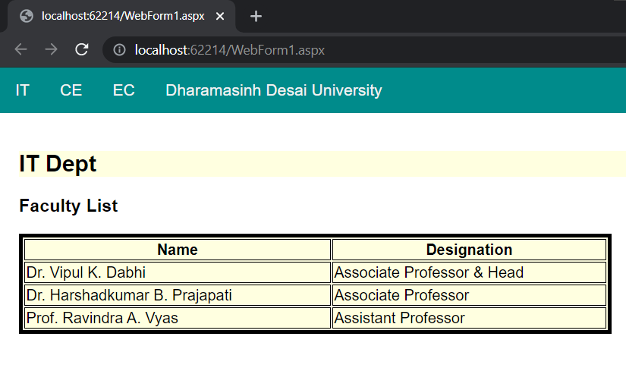

Fig. 1 IT Department Faculty List

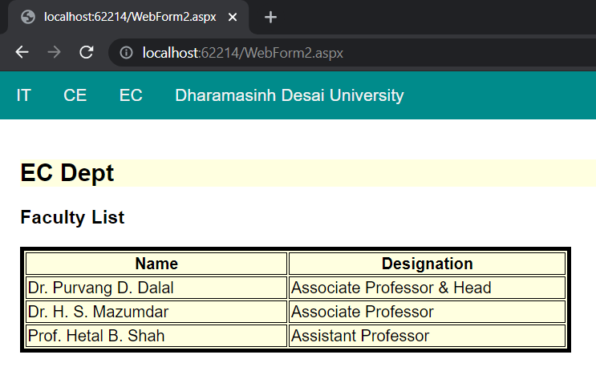

Fig. 2 EC Department Faculty List

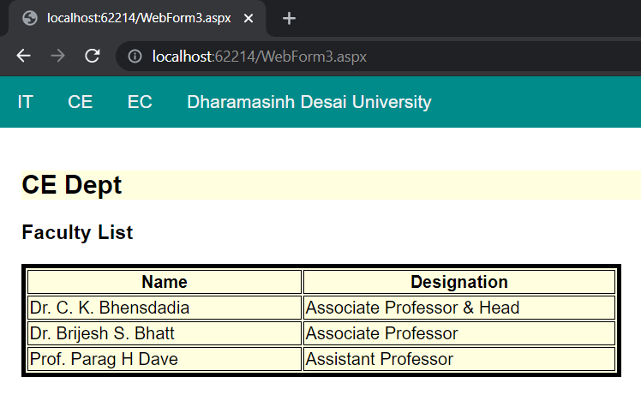

Fig. 3 CE Department Faculty List